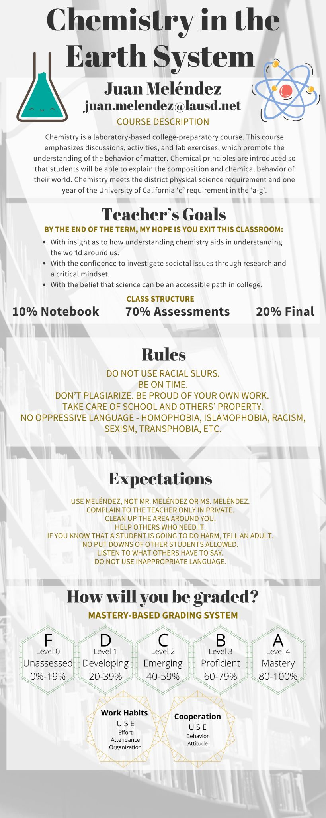

Annotate your syllabus. Write questions & clarifications in the area below.

Your name

___________________________________

Your signature

___________________________________

Parent signature

___________________________________